MINUTES OF A MEETING OF THE CLASSICAL ASSOCIATION TEACHING BOARD HELD ON 06 SEPTEMBER 2023 BY VIDEO LINK
Present: Prof. Sharon Marshall (Chair), Prof Arlene Holmes-Henderson (Vice Chair), Prof Judith Mossman, George Maher, Gráinne Cassidy, Katrina Kelly, James Renshaw, Dr Chris Burnand, Dr Jess Dixon, Rob Hancock-Jones
In attendance: Prof. Nick Lowe (CUCD), Alex Orgee (OCR), Steve Hunt (Journal of Classics Teaching), Prof Robin Osborne (Omnibus), Caroline Bristow (Cambridge School Classics Project), Hannah Walsh (Classics for All), Dr Liz Potter (CA Secretary), Jo Lashly (EDUQAS), Elizabeth Hayes (Sussex PGCE), Dr Aisha-Khan Evans (KCL)
Apologies: Dr Alex Imrie (CAS), Amber Taylor (CANI), Clare Harvey (SPRS Schools Committee), Prof Douglas Cairns
Absent: Lee Baker (SQA), Anastacia Holding, Dr Alex McAuley, Carolyn Saunders (ARLT), Hilary Hodgson (Classics for All)
2 Apologies and absences
Apologies have been received from Dr Alex Imrie, Amber Taylor, Clare Harvey and Prof Douglas Cairns.
3 Minutes of the last meeting
There were no amendments to the minutes of the meeting of the CA Teaching Board on 23 March 2023. The minutes were subsequently approved.
- Matters arising from the minutes:
All matters arising have been dealt with or are due for discussion during the meeting. One outstanding item is the potential for the CA to support CAS with policy engagement in education initiatives in Scotland. AHH has offered their support. GC will liaise with CAS once the Council has been formally reconvened.
4 Education Co-ordinator’s update
The report supplied was noted. Gráinne outlined that the focus for the half term ahead will be first of the CA’s online CPD days (for Classical CIvilisation), and the next round of Subject Team meetings, which will happen around October/November. AHH offered their support with policy liaison in Wales, and advice on relationship development with the Ashmolean.
5 Outreach Officer’s update
The report supplied was noted. The Chair thanked Arlene for her ongoing work, and explained that the title change as on the report to ‘Partnerships Officer’ has not yet been ratified by CA Council, but will be raised at the next meeting.
6 Engagement Co-ordinator’s update
Katrina gave a summary of the CA’s recent activities, including the new series of The Classics Podcast. At the meeting, Katrina couldn’t provide a clear indication of the number of proposals that had been submitted for CA Conference 2024 at Warwick as the deadline had only just passed (31 August), but did provide an overview of events that are being organised as part of the conference programme.
7 Subject Updates
The report supplied was noted. The Chair thanked the Team Leaders and the Subject Team members for their continued efforts to support the CA and the Education Co-ordinator with the ongoing development of the education programme.
- Classical Civilisation
Rob re-iterated his thanks to the CA and the Classical Civilisation Subject Team. Rob provided a summary of the resources that have been developed and are planned for the forthcoming year, and the CPD event running in October. AHH suggested that it would be useful to pull similar resources together (such as the CA’s recent videos and the BSA’s Homeric World videos). She also recommended using CfA’s Chorus as a forum if using student voice when developing resources. HW confirmed that the Chorus could be utilised in this way, and that CfA would be willing to use their new platform to host KS4/5 resources.
Rob explained that the Subject Team has been working on developing proposals for the GCSE specification, and that as Team Leaders for Classical Civilisation and Ancient History, he and James Renshaw had met with OCR to discuss the development work in both subject areas, to ensure the two subjects remained distinct.
Rob highlighted the concerns that have been raised on social media regarding the grading of the GCSE, and that teachers aren’t raising individual complaints with OCR as the process is demoralising. Rob suggested that the CA could support with defining a complaints process that enables teachers to feel listened to.
- Ancient History
James Renshaw noted the newly published A Level Ancient History Sourcebooks that were released last week.
Prior to the meeting, James had sent out a short survey to his network of teachers asking for feedback on the most recent exam series. Additionally, James had analysed the publicly available data that demonstrates that in comparison to Classical Civilisation and Modern History, it is more challenging to achieve an A* in A Level Ancient History:
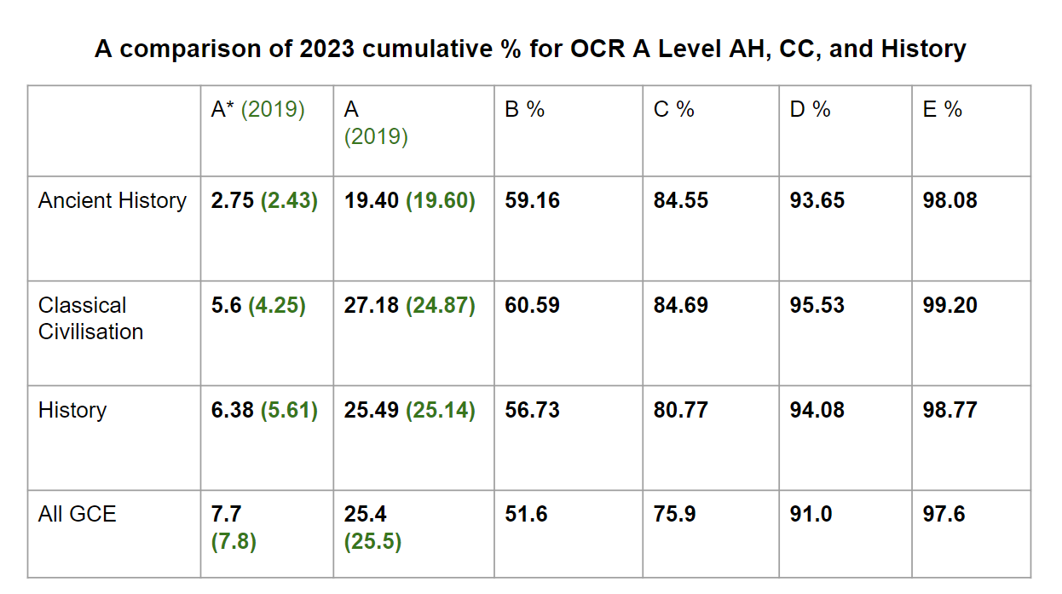
SH and CBu reiterated James’ concerns that the grading of A Level Ancient History is too severe and is restricting the development of the subject and that this ought to be a priority for OCR.
AO shared data that demonstrates that the prior attainment of the 2023 A Level Ancient History cohort is weaker than the 2023 A Level Classical Civilisation cohort and OCR’s A Level History cohort in 2023 which would help explain why outcomes were generally lower in Ancient History. CBr queried whether there were more difficulties using prediction matrices in qualifications with small cohorts. AO confirmed that OCR uses other statistical data rather than prediction matrices for Classical Greek when awarding grade boundaries. AO has alerted the relevant people in OCR about the concerns that have been raised about A Level Ancient History grading. AO also shared a guide that explains how OCR ensures marking accuracy.
Following the meeting, The Chair, Education Co-ordinator and Subject Team Lead for Ancient History submitted a complaint to OCR, to which they responded on 17.10.23.
- Latin
Jess confirmed that she has not received any negative feedback regarding this summer’s exam series, but noted that on social media, concern had been raised as to the wording of a question on an Eduqas exam. Jess also suggested that it might be useful for the CA to create support materials for the OCR Literature & Culture paper, although the focus for the language teams this coming academic year are the Greek GCSE translations and the Inclusive Unseens project.
- Greek
Chris explained that the biggest concern following Greek exams this summer had been the difficulty of the Verse unseen paper at A Level. As with other subject areas, this is being expressed most prolifically on social media, with individuals requesting data or support from other centres in order to submit complaints letters to OCR. SM suggested that members of the CATB could aim to anticipate problems prior to the start of an exam series, in order to make clear to the teaching community what the most effective way is to raise a concern or complaint.
Chris confirmed that the team will begin working on translations for the new set texts after Christmas. Translations for future set text cycles will be produced by Bloomsbury.
Regarding the Qualifications Review, Chris is currently working with a small team (including members of the Latin Subject Team) to review proposals for changes to the Literature examinations.
The ICCG report was also noted - it has been another successful year for the team.
ACTION: CATB to consider what to be aware of ahead of each exam cycle, and to create a one-page document that explains the complaints process to teachers.
8 National Updates
The reports provided were noted. The Chair thanked Alex and Amber for their work.
9 CA Business: Publications
- JCT
The report was noted. Steve formally thanked those who act as peer reviewers, including Evelien Bracke, Cressida Ryan, Arlene Holmes-Henderson and Aisha Khan Evans.
- Omnibus
The report supplied was noted. The new release will be released imminently. Robin would welcome feedback on the articles included and further suggestions for articles, especially ‘big book’ pieces that explore landmark scholarship.
10 Proposals for changes to the structure of CATB
The Chair explained that the motivation for this proposal was to reflect the increased output of the CATB and the subject teams, owing to the employment of the Education Co-ordinator, and the need to create greater space for strategic thinking in relation to education without creating further meetings. In teasing apart the more operational (CATB) and more strategic (CDG), the aim is to create space for both conversations, keeping the operational activities at the heart of the CATB and recognising the increasingly important role played by the subject teams, whilst not excluding anyone from either conversation or duplicating work.
Queries were raised as to how the groups relate, whether there would be cross-representation at the different boards, who would be responsible for communication between the boards, and where certain CATB members and invited observers would be best placed. It was felt by some that the PGCE leads, as the primary source of new pedagogical research in Classics, ought to be members, rather than invited observers. Additionally, it is important for universities to be present at CATB as issues discussed here are then taken to CUCD.
ACTION: GC/SM to continue this conversation with CATB members, before making amendments to the proposal that will be taken to CA Council.
11 Job Descriptions for Chair of CATB & Subject Team Leaders
The suggestions made for amendments to both documents were noted.
ACTION: GC/SM to make necessary amendments to JDs before taking them to Council.
12 Exams Update
- OCR
The report supplied was noted. CBr raised the report produced by Philip Pratt that has been circulated on socials regarding the grading of GCSE. Alex confirmed that OCR had received the report and that he has done some further research using the data on the Ofqual Analytic page, but stated that it is vital for OCR to hear from individual schools so that they are aware of the scale of the concerns. GM has offered his experience in analysing data to help bolster a case and inform CATB’s decision-making regarding priorities for research .
ACTION: GM to analyse the data at GCSE and A Level to support the CATB in prioritising research to commission.
- Eduqas
The report supplied was noted. Jo felt that, based on the quality of student responses, it was too early to return to pre-pandemic standards, to which the Welsh Board responded well. Following comments raised on social media, Jo confirmed that the set texts for Component 3A in 2026/27 will be Hannibal crossing the Alps and the Story of Cacus from Aeneid VIII.
- SQA
The report supplied was noted.
13 Ideas generation for CATB research priorities
The Chair stated that, as had become clear from the conversations earlier in the meeting, the priority for future research would be analysing exams data. AHH offered support in accessing data and comparative analysis from the DfE data team. She also confirmed that the British Academy’s National Committee for Languages is currently funding research into barriers to uptake, and so specific requests could also be fed into this.
ACTION: AHH to request at the British Academy’s National Committee for Languages that the Classics community would welcome research into how the relative difficulty of subjects affects uptake.
14 Date of next meeting - AGM
The Chair requested the members of CATB to complete the Google Form. Suggestions for low-cost venues would be welcomed.
ACTION: All to complete this form.
15 AOB
The Chair asked for an update from each of the PGCE Leads:
- Cambridge: Steve confirmed that recruitment has been difficult this year. Nationally, the numbers joining PGCE courses is low. The target at Cambridge is 19 per year. This September, 14 are starting the course, which is the lowest it has been for some time.
- KCL: Aisha confirmed that KCL have faced similar issues - their target is 21 (with the understanding that an average of 3 won’t start the course). This September, 14 are starting the course.
- Sussex: Lizzy confirmed that they have also struggled, and recruitment has been ongoing all through the summer period. The target at Sussex is 10, with 7 starting the course this September. Sussex has partnered with Chicester who will award QTS whilst Sussex pursue reaccreditation.
- Durham: the PGCE course will run this academic year, but will be paused from September 2024 whilst reaccreditation is pursued, with the hope of course starting once more in 2025. Newcastle, who currently award QTS for the Durham PGCE, will not continue to do so for courses they are not directly accredited to award. Arlene is currently unclear on how many are starting the course this September - this is managed by the MFL PGCE, with Arlene providing subject-specific support.
SH commented that the King Edwards Consortium has 1 starting this September, with numbers currently unclear for the Liverpool SCITT.
ACTION: SM to liaise with the PGCE leads regarding an online recruitment event for university students.

Close of meeting: 06:12pm
Prof. SHARON MARSHALL, CHAIR

